Djibouti

## GNI per capita and development level

The data set shows the GNI per capita and development level of the country each year.

## # A tibble: 19 x 5  
## country iso3c date GNIperCapita devCategory   
## <chr> <chr> <dbl> <dbl> <chr>   
## 1 Djibouti DJI 1996 35932. High Income   
## 2 Djibouti DJI 1998 35932. High Income   
## 3 Djibouti DJI 2000 35932. High Income   
## 4 Djibouti DJI 2002 1525. Lower Middle Income  
## 5 Djibouti DJI 2003 36761. High Income   
## 6 Djibouti DJI 2004 36841. High Income   
## 7 Djibouti DJI 2005 37174. High Income   
## 8 Djibouti DJI 2006 36761. High Income   
## 9 Djibouti DJI 2007 5566. Upper Middle Income  
## 10 Djibouti DJI 2008 36010. High Income   
## 11 Djibouti DJI 2009 35011. High Income   
## 12 Djibouti DJI 2010 1364. Lower Middle Income  
## 13 Djibouti DJI 2011 34961. High Income   
## 14 Djibouti DJI 2012 1164. Lower Middle Income  
## 15 Djibouti DJI 2013 1372. Lower Middle Income  
## 16 Djibouti DJI 2014 34284. High Income   
## 17 Djibouti DJI 2015 33747. High Income   
## 18 Djibouti DJI 2016 33747. High Income   
## 19 Djibouti DJI 2017 1372. Lower Middle Income

## GDP growth and economic growth classification

The data set shows the GDP growth and the ecomic growth classification of the country each year.

## # A tibble: 19 x 5  
## country iso3c date GDPannualGrowthRate GDPgrowthCategory4  
## <chr> <chr> <dbl> <dbl> <fct>   
## 1 Djibouti DJI 1996 4.90 moderate growth   
## 2 Djibouti DJI 1998 5.90 fast growth   
## 3 Djibouti DJI 2000 5.50 fast growth   
## 4 Djibouti DJI 2002 5.40 moderate growth   
## 5 Djibouti DJI 2003 5.90 fast growth   
## 6 Djibouti DJI 2004 6.65 fast growth   
## 7 Djibouti DJI 2005 6.65 fast growth   
## 8 Djibouti DJI 2006 5.90 fast growth   
## 9 Djibouti DJI 2007 11.0 fast growth   
## 10 Djibouti DJI 2008 5.81 fast growth   
## 11 Djibouti DJI 2009 5.90 fast growth   
## 12 Djibouti DJI 2010 3.20 moderate growth   
## 13 Djibouti DJI 2011 4.40 moderate growth   
## 14 Djibouti DJI 2012 5.33 moderate growth   
## 15 Djibouti DJI 2013 5.33 moderate growth   
## 16 Djibouti DJI 2014 7.06 fast growth   
## 17 Djibouti DJI 2015 7.70 fast growth   
## 18 Djibouti DJI 2016 6.65 fast growth   
## 19 Djibouti DJI 2017 5.40 moderate growth

## Development trend

The plot shows the development trend of the country.

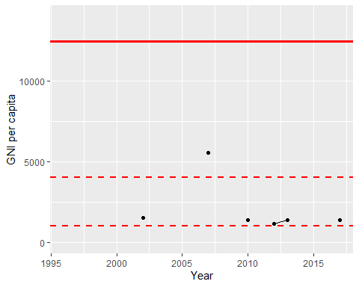

GNI Per Capita Trend